Technological University of León CAMPUS Acambaro SOUTHEAST ACADEMIC UNIT

AREA INFORMATION TECHNOLOGY AND COMMUNICATION

ACTIVITIES DOCUMENT



AVOINE

PRESENTS

|  |  |  |
| --- | --- | --- |
| 15001016 | JOSE ALFREDO BLANCO ARMENTA | [fredie.ab@gmail.com](mailto:fredie.ab@gmail.com) |
| 15002108 | VELAZQUEZ MANUEL MARTÍNEZ | [akiaseruygo@gmail.com](mailto:akiaseruygo@gmail.com) |
| 15001266 | ANDY GARCIA MORENO | [andresmorgar@gmail.com](mailto:andresmorgar@gmail.com) |
| 15000922 | MORA LAURA PATRICIA RANGEL | [Pato_123_56@hotmail.com](mailto:Pato_123_56@hotmail.com) |

TEACHER

MAYRA RIVERA NELI Pizaña

MATTER

PROJECT MANAGEMENT FOR ITI

GROUP

ITI-801

GENERATION: 2017-2019.

Acambaro, Guanajuato. February 11, 2018.

**CONTENT**

CONTENT 3

TABLE OF ACTIVITIES 3

LIFECYCLE 6

JUSTIFICATION OF LIFE CYCLE 9

CONCLUSIONS 10

MORA LAURA PATRICIA RANGEL 10

JOSE ALFREDO BLANCO ARMENTA 10

MANUEL VELAZQUEZ MARTÍNEZ 11

ANDRES MORENO GRÀCIA 11

# CONTENT

## TABLE OF ACTIVITIES

|  |  |  |
| --- | --- | --- |
| Activity | Description | Responsable |
| **planning** | | |
| Proyect Plan | Define the actions estimated to reach completion of the project. | Work team |
| Documentation | Documenting planned for the start of the project. | documenter |
| **Analysis** | | |
| Methodology | Define the methodology to be followed for the project. | Project Leader |
| Define data collection strategy | The means to use to obtain the necessary project information. | Project Leader |
| problematic | Define the main problem of the company to develop this application. | Project Leader  Analyst |
| Background | define if exist a history of other applications for the problem. | Project Leader  Analyst |
| Justification | Justify why the application is made. | Project Leader  Analyst |
| **goals**  general  methodologic  Scope | Define the overall objective of the project, a methodology for activities, define the scope of the project. | Project Leader  Analyst |
| **requirements**  functional  nonfunctional | Define what the application will perform and does not perform. | Project Leader  Analyst |
| Documentation | Archiving and record changes in the project's progress | documenter |
| **Design** | | |
| I formated | Design sketches application. | Designer |
| ER diagrams | Designing the ER diagrams database | Analyst  programmers |
| UML diagrams | UML diagrams to design the database | Analyst  programmers |
| Navigation map | Make the navigation map application. | Designer |
| Documentation | Archiving and record changes in the project's progress | documenter |
| **Coding** | | |
| Coding database | Perform the database according to the diagrams. | programmers |
| frontend programming | Scheduling features side users. | programmers |
| Backend programming | Administrator program functionality side. | programmers |
| Documentation | Archiving and record changes, problems in the progress of project documentation. | programmers  documenter |
| **Tests** | | |
| Unit tests | Check the project to check its functionality. | Tester |
| System Tests | Check the project to review the system. | Tester |
| Quality Testing | Check the project to review the quality of the project. | Tester |
| Documentation | Archiving and record changes, problems in the test project. | documenter |
| **Implementation** | | |
| Show application | Show the final application to customers. | Project Leader  programmers |
| System Tests | Testing of the system to customers. | Tester |

## LIFECYCLE

**Waterfall lifecycle**

This type of life cycle is characterized as the most used and one of the oldest as well as being the most effective is known by different names such as classical and traditional model among others is a cycle that follows a methodology in stages since it is strictly carried out under a hierarchy or sequence.

This cycle demands that the next phase should not begin until the previous phase is completed. In practice, these stages overlap and provide information to others. And during the design problems and code requirements are identified.

* **Life cycle stages**
* **Engineering and System Analysis:** Because the software is always part of a larger system work begins by establishing the requirements of all system elements and then allocating some subset of these requirements to software (this stage develops when part of a system already developed).
* **Analysis software requirements:** the process of gathering requirements focuses and intensifies especially in the software. Software engineer (Analysts) must understand the scope of information software, as well as function, performance and required interfaces.
* **Design:**Software design focuses on four distinct attributes of the program: data structure, software architecture, procedural detail and characterization of the interface. The design process translates requirements into a representation of the software with the required quality before coding begins.
* **Coding:** The design must be translated into machine readable form. Coding step performs this task. If the design is made in detail for the encoding may be performed mechanically.
* **Proof:**Once it generated the code begins testing program. The test focuses on the internal logic of the software, and external functions, performing tests to ensure that defined input produces results that are actually needed.
* **Maintenance:**The software will undergo changes after it is delivered to the customer. Changes will occur because errors have been found, the software must be adapted to changes in the external environment (operating system or peripheral devices), or because the customer requires functional or performance enhancements.

* **Advantage:**
* It is a simple method as follows intuitive steps when developing software.
* It allows a more controlled administration of the project.
* It is an effective process that serves to deliver the project in a timely manner.
* Since it is a hierarchical process allows a step is performed before finishing another.
* Helps keep the team assigned to their tasks and communication avoids confusion.
* **disadvantages:**
* The waterfall model is very flexible and does not contemplate returning to a given stage if it has to break up the stage to be changed.
* Normally, it is difficult for the client explicitly set at the beginning all requirements. The classic life cycle requires it and has difficulty in accommodating possible changes.
* The model does not contemplate the possibility of return to immediately preceding stages, which can occur in reality.

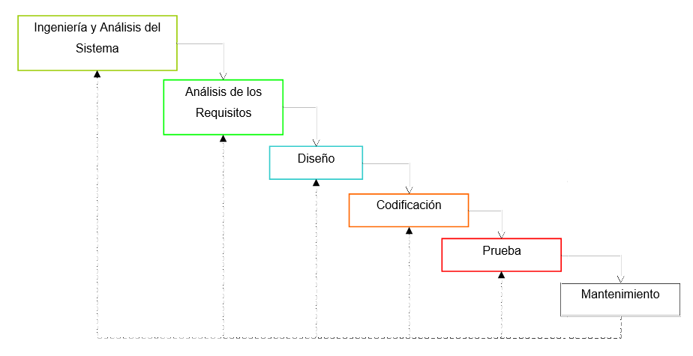

## JUSTIFICATION OF LIFE CYCLE

life cycle waterfall be used as it is one of the most common and easy to understand, besides facilitating the project because it is given more control when using this method is safer to compliance with the project in a timely manner.

Additionally, it can be said that a life cycle of the safest, as to finish a certain phase may not advance to the next and the risk of failure and loss of time decreases.

# CONCLUSIONS

## MORA LAURA PATRICIA RANGEL

The development of this activity will be of great support during our training as engineers and in it they were embodied each of the aspects that has a project detailing all the tools to be used during development also helps us not forget as both full documentation of a project like the content of this is done.

I personally believe that this activity helps us to attach ourselves more to the reality of a professional also perfected project more the way we seek information on the Internet and improve on the drafting of any part of this document as well as communication with peers.

## JOSE ALFREDO BLANCO ARMENTA

In conclusion, this activity shows the sequence of activities and steps followed in the development of a software project, which is very important as this must have a very strict order for the development of any system in a company . These activities are very important because they show us how it should be documented roughly into a company that develops software that helps us know what to do once we meet in the workplace at least have a notion of how is that working in enterprises.

## MANUEL VELAZQUEZ MARTÍNEZ

In this activity, we carry out the methodological objectives for the project, these are very important, because in them, goals are specified to be achieved in each project phase and these may vary in quantity, the theoretical framework is also included, table activities, and the cycle of life, these activities will help my professional development in a big way, because I can keep better control and organization development of my project, and even work in a more organized manner, resembling what the labor camp development company. And even I will be able to get more competitive when making a project.

## ANDRES MORENO GRÀCIA

Knowing the information about the development of different types of projects is important for our career, and we acquire and / or we return information about previous issues that are not important.

Most of these issues comprise a very important area for the good development of projects such as the definition of project scope, methodology, requirements etc.

I think it's important for us to know this information and to develop each of them in a right way, to gain experience in the workplace, while working with colleagues from areas other than the area in which we are accustomed.